# Working from home is good for company

# Notes

1 he has a deeper and more broad knowledge than I do.

He has a deeper and more broad knowledge than I do.

2 more difficult to work together

more difficult to work together

3 The boss will monitor their laptop.

The boss willl monitor how much work I get done.

The boss will monitor employeers’ laptop and calculate how much work the employer has done.

4 saving commuting time; can concentrate more (less interruptions); can work at the time that best suits you.

Saving commuting time; can concentrate more (less interruptions); can work at the time that best suits you

I think we should work in pairs because of the number of questions.

Because of the number of questions, I think we should work in pairs.

|  |  |  |  |  |
| --- | --- | --- | --- | --- |
| Perspective | /pəˈspektɪv | | | The way you think about something  From another perspective  Historical perspective 历史展望 |
| appropriate  suitable | /əˈprəʊpriət/ | | | Suitable or right for a particular situation or occasion  Appropriate time |
| Situation  occasion | /ˌsɪtʃuˈeɪʃ(ə)n/ /əˈkeɪʒ(ə)n/ | | |  |
| sufficient  enough | /səˈfɪʃ(ə)nt/ | | | As much as is necessary |
| To demonstrate | /tu ˈdemənstreɪt/ | | | To show or prove that something exists or is true  To demonstrate by one’s action |
| To provide | prəˈvaɪd | | | To give someone something that they need |
| To justify  explain | ˈdʒʌstɪfaɪ | | | To give or to be a good reason for something  Justly公正  Justified 有正当理由的  Justifiable 有道理的 |
| I think | | | Audience | |
| I strongly believe.. | | | Biases /ˈbaɪəsɪz/ | |
| From my perspective | | | Assumption /əˈsʌmpʃn/ | |
|  | | |  | |
| Manager  Employee 员工  Employer 雇主 = boss | | | Convince /kənˈvɪns/  Assure, reason  convincing | |
| Monitor laptop /computers | | | Deadline /ˈdedlaɪn/  Meet a deadline 按期完成  the point in time at which something must be completed | |
|  | |  | | |
| Boss | | … studies show that employees who work from home work more hours every month and get more work done | | |
| Co-worker | | … employees don’t have to commute and can spend more time with their families | | |
| Human Resource department | | …companies can hire top experts from around the world instead of being limited to employees in their city | | |
| client | | …cost for a physical office are lower, so products can be cheaper. | | |

[cambly.com/en/student/courses/6010b1e58095ca133d23482a/60bfd03298050fe3707082e7](https://www.cambly.com/en/student/courses/6010b1e58095ca133d23482a/60bfd03298050fe3707082e7)

# lesson contents

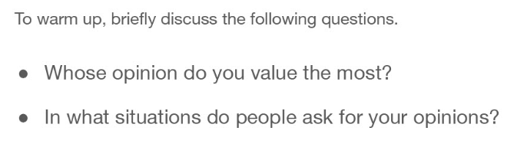

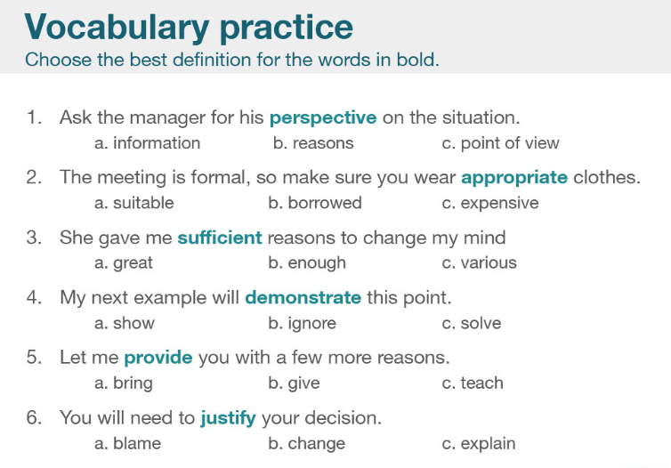

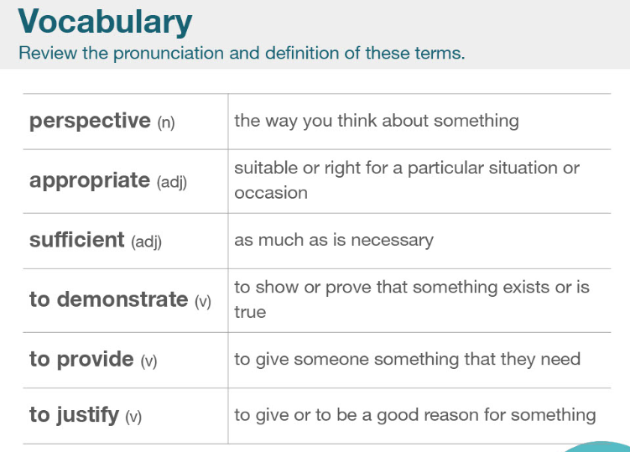

|  |  |  |
| --- | --- | --- |
| Perspective | /pəˈspektɪv | The way you think about something  From another perspective  Historical perspective 历史展望 |
| appropriate  suitable | /əˈprəʊpriət/ | Suitable or right for a particular situation or occasion  Appropriate time |
| Situation  occasion | /ˌsɪtʃuˈeɪʃ(ə)n/ /əˈkeɪʒ(ə)n/ |  |
| sufficient  enough | /səˈfɪʃ(ə)nt/ | As much as is necessary |
| To demonstrate | /tu ˈdemənstreɪt/ | To show or prove that something exists or is true  To demonstrate by one’s action |
| To provide | prəˈvaɪd | To give someone something that they need |
| To justify  explain | ˈdʒʌstɪfaɪ | To give or to be a good reason for something  Justly公正  Justified 有正当理由的  Justifiable 有道理的 |

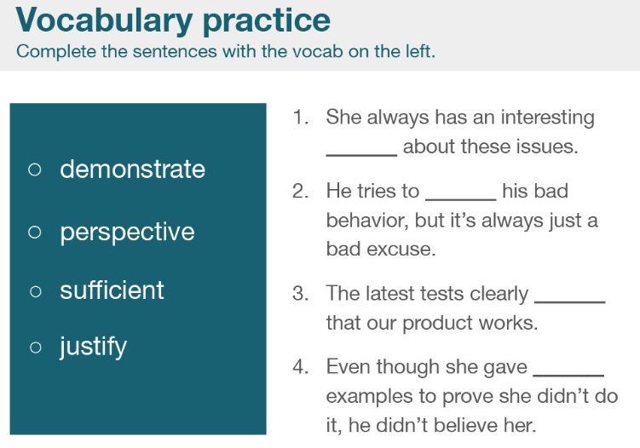

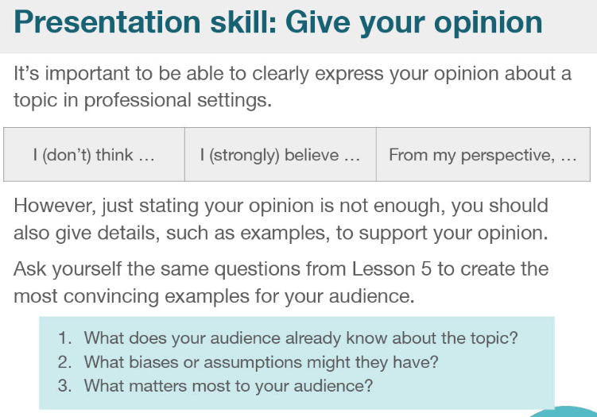

|  |  |
| --- | --- |
| I think | Audience |
| I strongly believe.. | Biases /ˈbaɪəsɪz/ |
| From my perspective | Assumption /əˈsʌmpʃn/ |
|  |  |
| Manager  Employee 员工  Employer 雇主 = boss | Convince /kənˈvɪns/  Assure, reason  convincing |
| Monitor laptop /computers | Deadline /ˈdedlaɪn/  Meet a deadline 按期完成  the point in time at which something must be completed |

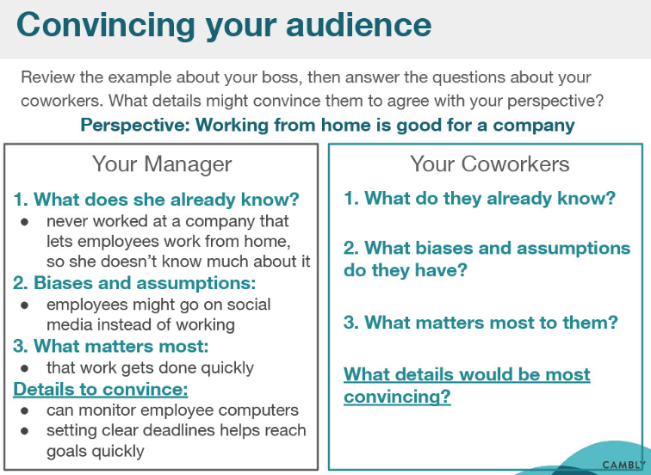

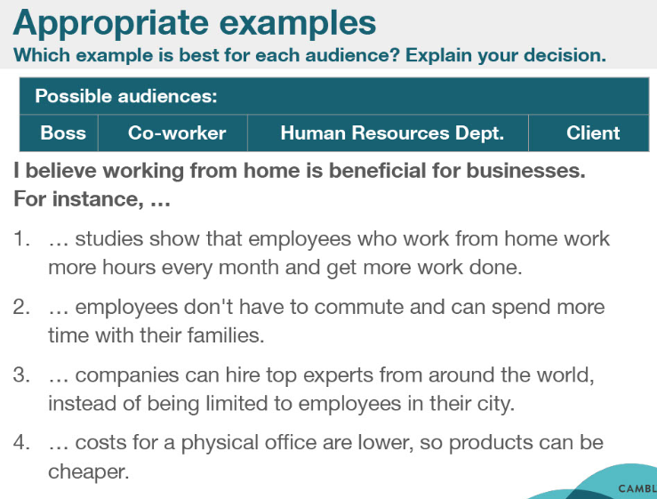

|  |  |
| --- | --- |
|  |  |
| Boss | … studies show that employees who work from home work more hours every month and get more work done |
| Co-worker | … employees don’t have to commute and can spend more time with their families |
| Human Resource department | …companies can hire top experts from around the world instead of being limited to employees in their city |
| client | …cost for a physical office are lower, so products can be cheaper. |

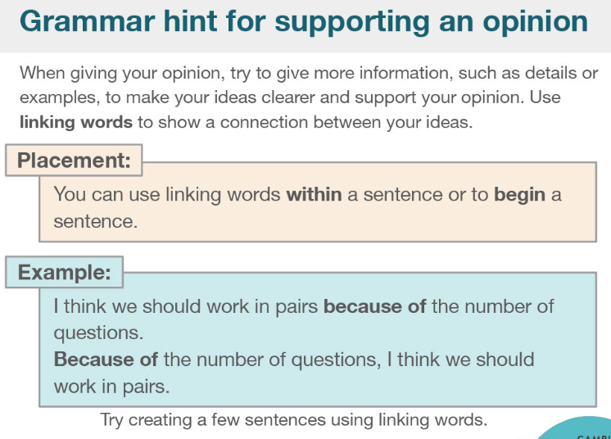

I think we should work in pairs because of the number of questions.

Because of the number of questions, I think we should work in pairs.

